CRICKSTATS – SALESFORCE CAPSTONE PROJECT
PHASE 6 – PROJECT TESTING
CRICKET PLAYER PERFORMANCE TRACKING APPLICATION
Information | Details
Project Title | CRICKET PLAYER PERFORMANCE TRACKING APPLICATION  CRICKSTATS
Project Domain | Cloud Computing / Salesforce Administration
Platform | Salesforce Lightning Developer Edition
Team Leader | Saravanan S - (Reg. No. 24134031802521044)
Member 2 | SRIVARSHAN S- (Reg. No. 24134031802521048)
Member 3 | Tamilselvan S- (Reg. No. 24134031802521051)
Member 4 | Karthi Karthi- (Reg. No. 24134031802521020)
Member 5 | Barathiraja R- (Reg. No. 24134031802521013)
Institution | PS PT MGR GOVERNMENT ARTS & SCIENCE COLLEGE, SIRKALI, PUTHUR-609108 (College Code: ANM403)
Submission Portal | SkillWallet / Naan Mudhalvan

1. Testing Objective
Testing verifies that the implemented CRICKSTATS features work correctly and that performance requirements are satisfied.

2. Functional Testing
Test Area | What to Verify | Expected Result
Player Object | Create player record | Player record is saved correctly
Match Performance | Create match-performance record | Match data is saved and related to Player
Validation | Mandatory fields, score limits and input constraints | Invalid input is prevented
Record Categories | Domestic and International match categories | Correct category behavior is displayed
Roll-up Summary | Runs, wickets, averages and performance metrics | Calculated values update accurately
Flow | Team selection and player statistics display | Flow executes and displays consistent data
Reports | Generated performance reports | Report data matches stored records
Dashboard | Charts and statistics | Dashboard visualizations update correctly

3. Performance Testing
- Monitor response time during data entry.
- Check report-generation response time.
- Check dashboard loading and rendering.
- Test multiple user interactions for stable performance.
- Verify that the application remains responsive without unnecessary delays.

4. Test Evidence / Screenshots

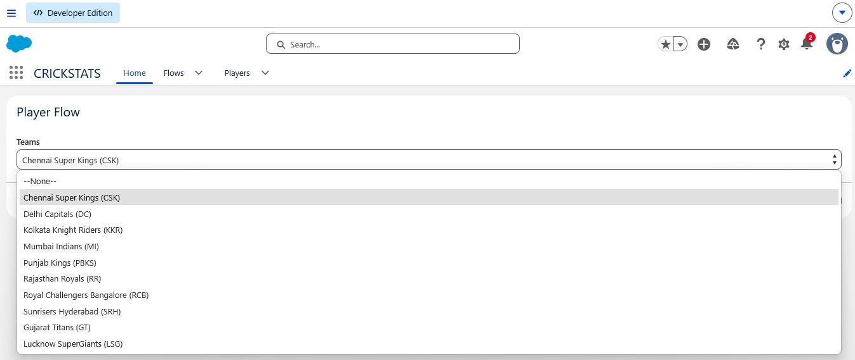

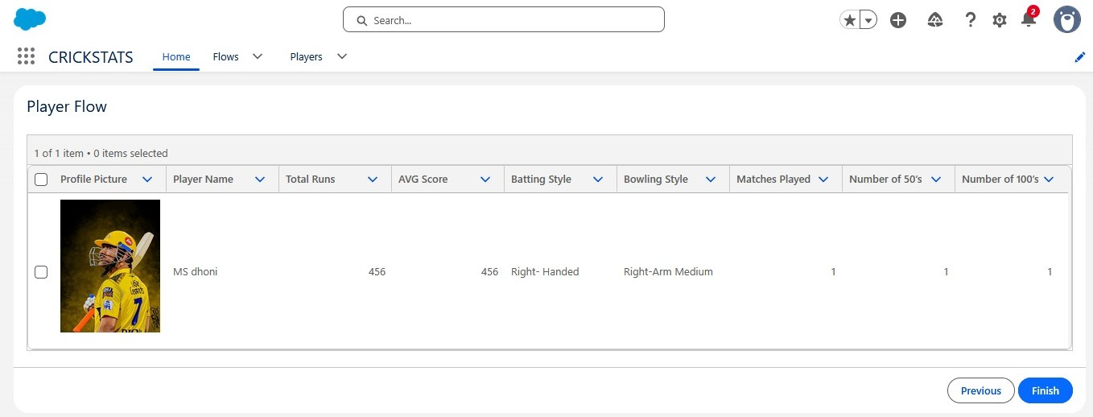

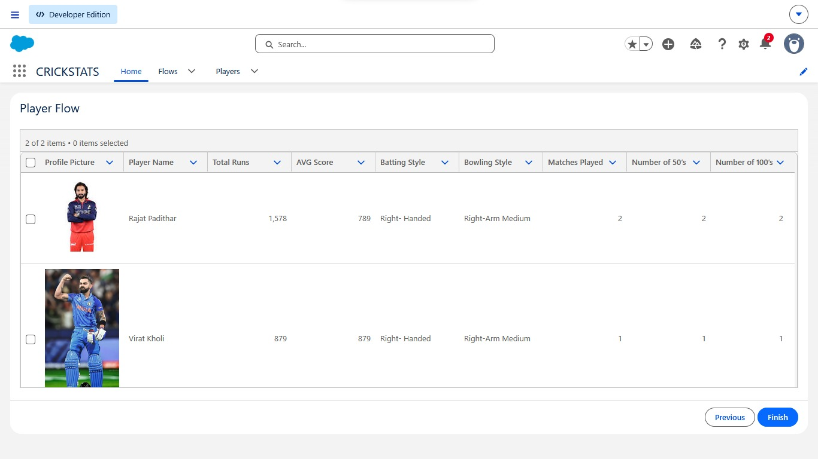

5. Test Result Summary
The reference documentation states that screenshots were captured to verify record creation, validation checks, record-type behavior, flow execution, roll-up summaries, reports and dashboards. Performance was also evaluated during data entry, report generation and dashboard loading.

6. Phase Conclusion
Testing confirms the implemented CRICKSTATS features and performance behavior before deployment, provided the required records are entered for testing.

